FORECAST-DRIVEN ENERGY-AWARE SCHEDULING FOR SMART MANUFACTURING

AD23A38 – Manufacturing Analytics
Project Report

Submitted by
Hemanth Kumar D 231801057
Balaji R 231801018
Bijlesh S 231801501

Department of Artificial Intelligence and Data Science

(An Autonomous Institution, Affiliated to Anna University, Chennai)
SEPTEMBER 2026



BONAFIDE CERTIFICATE

Certified that this mini-project report “Forecast-Driven Energy-Aware Scheduling for Smart Manufacturing” is the bonafide work of Hemanth Kumar D ( 231801057) , Balaji R (231801018) , Bijlesh S (231801501) VII Semester, B.Tech. Artificial Intelligence and Data Science Department in partial fulfilment of the requirements of the course AD23A38 – Manufacturing Analytics during the Academic Year 2026 – 2027.

Faculty in-charge

Submitted to mini-project viva voce examination held on: ………………………

INTERNAL EXAMINER EXTERNAL EXAMINER
ACKNOWLEDGEMENT

We begin by expressing our deepest gratitude to the Almighty for guiding us through every step of this journey and for blessing us with the strength and clarity to complete this work. We sincerely thank our respected Chairman Mr. S. Meganathan, B.E., F.I.E., our Chairperson. Dr. (Mrs.) Thangam Meganathan, Ph.D., and our Vice Chairman Mr. Abhay Shankar Meganathan, B.E., M.S., for providing excellent infrastructure and for their unwavering commitment to quality education. We place on record our sincere thanks to Dr. S. N. Murugesan, M.E., Ph.D., our beloved Principal, for his continuous support and for providing the facilities required for the successful completion of this project. We express our heartfelt gratitude to Dr. J M Gnanasekar, Ph.D., Professor and Head of the Department, for his valuable guidance, encouragement, and constructive feedback throughout the course of this project. Our deepest thanks go to our internal guide and project coordinator, Mrs. Savithri R, for her patient mentorship, valuable suggestions, constant encouragement, and continuous support throughout the development of our " Forecast-Driven Energy-Aware Scheduling for Smart Manufacturing " project. We also wish to thank all the faculty members and teaching staff of the Department of Artificial Intelligence and Data Science for their encouragement and for sharing their valuable knowledge with us. Finally, we express our sincere gratitude to our families and friends for their constant support, motivation, and patience throughout this endeavour.

TABLE OF CONTENTS
S.No. | Title | Page No.
1 | INTRODUCTION | 6
1.1 | Overview of the Problem Domain | 6
1.2 | Energy-Aware Scheduling | 6
1.3 | Role of Forecasting | 7
1.4 | Electricity Tariffs | 7
1.5 | Objectives and Scope | 8
2 | PROBLEM STATEMENT | 9
3 | DATA SET DESCRIPTION & PREPROCESSING | 11
3.1 | Data Set Description | 11
3.2 | Manufacturing Jobs and Machine Environment | 11
3.3 | Preprocessing and Feature Engineering | 12
3.4 | Synthetic Benchmark and Scheduling Horizon | 13
3.5 | Training, Testing and Preprocessing Outcome | 13
4 | MODEL DEVELOPMENT & METHODOLOGY | 15
4.1 | Overall Methodology | 15
4.2 | Model Selection and Forecasting Methodology | 15
4.3 | Scheduling Algorithms and Priority-Based Tariff Shifting | 17
4.4 | Hybrid CP-SAT Optimization and Objective Formulation | 19
4.5 | Complete Scheduling Methodology and System Implementation | 20
5 | METRICS TO MEASURE | 21
5.1 | KPI Selection | 21
5.2 | Energy and Cost Performance Metrics | 22
5.3 | Manufacturing and Production Performance Metrics | 23
5.4 | Service-Level and Environmental Metrics | 23
5.5 | Multi-Dimensional Evaluation | 24
6 | RESULT REVIEW | 25
6.1 | Benchmark Results | 25
6.2 | Energy Cost and Production Performance | 26
6.3 | Peak Load, Deadline and Environmental Performance | 27
6.4 | Overall Comparison and Interpretation | 28
6.5 | Dashboard and Visualization | 29
6.6 | Result Limitations | 29

1. INTRODUCTION
Overview of the Problem Domain
Modern manufacturing industries need to improve production efficiency while reducing operational costs, energy consumption, peak power demand, carbon emissions, and production delays. Manufacturing scheduling is inherently complex because it involves multiple heterogeneous machines, different job processing requirements, machine compatibility, setup and changeover requirements, arrival times, priorities, and production deadlines.
Traditional scheduling methods such as First-Come-First-Served (FCFS), Shortest Processing Time (SPT), Longest Processing Time (LPT), and Earliest Due Date (EDD) primarily focus on production-related factors such as processing time, machine availability, workload, and deadlines. These approaches generally do not account for changing electricity tariffs, machine-level energy consumption, or forecasted future energy conditions. As a result, energy-intensive manufacturing operations may be scheduled during expensive peak-tariff periods, increasing overall energy costs and peak power demand.
Modern smart manufacturing therefore requires scheduling approaches that consider both production requirements and energy-related factors. Manufacturing Analytics provides a way to address this challenge by integrating industrial data preprocessing, feature engineering, machine learning-based forecasting, heuristic scheduling, constraint-based optimization, and performance visualization.

Energy-Aware Scheduling
The proposed system implements a Predict-then-Optimize Framework that integrates probabilistic energy forecasting with manufacturing scheduling. The framework considers job arrival time, processing duration, priority, deadline, machine compatibility, sequence-dependent setup requirements, machine active and idle power, setup power, Time-of-Use electricity tariffs, forecasted future energy conditions, and peak grid-load constraints. The scheduling framework first generates forecasts of future energy conditions and then uses these predictions to support energy-aware scheduling decisions. Flexible manufacturing jobs can be shifted toward lower-cost periods when machine compatibility, production priorities, and deadline constraints permit.
The framework includes both heuristic and constraint-based scheduling methods. The proposed Forecast-Driven Priority Dispatching with Tariff Shifting (FD-PDTS) methods use forecast information to prioritize and position jobs, while an OR-Tools CP-SAT optimization model can refine the resulting schedule. The hybrid approach uses the FD-PDTS Robust schedule as a warm-start solution for CP-SAT.

Role of Forecasting
Historical industrial energy data is processed through a preprocessing and feature-engineering pipeline and used to forecast future energy behaviour. The project uses multi-quantile XGBoost models to generate probabilistic predictions rather than relying only on a single expected value. For active energy consumption and carbon emissions, the forecasting engine generates p10, p50, and p90 predictions, representing optimistic lower-bound, median expected, and conservative upper-bound energy conditions. Power factor is forecast using a p50 model.
The forecasting models use tariff-based sample weighting so that observations associated with higher-load tariff periods receive greater importance. To maintain valid quantile ordering, an observation-level monotone rearrangement is applied to enforce p10 ≤ p50 ≤ p90. The forecasting process also performs recursive multi-step prediction for the 48-hour scheduling horizon, dynamically updating lag and rolling statistical features at each forecast step. These forecasts provide the scheduling engine with information about expected future energy and carbon conditions.

Electricity Tariffs
The system considers a three-level Time-of-Use (ToU) electricity tariff structure:
Tariff Period | Operating Hours | Cost
Light Load (Off-Peak) | 22:00 – 06:00 | ₹4.00/kWh
Medium Load (Mid-Peak) | 06:00 – 08:00, 18:00 – 22:00 | ₹7.50/kWh
Maximum Load (Peak) | 08:00 – 18:00 | ₹12.00/kWh

The scheduler attempts to shift flexible manufacturing operations toward lower-cost tariff periods while respecting machine compatibility, job availability, priority-based shifting limits, setup requirements, and production deadlines. Peak grid demand is also considered through a soft peak-load guard.

Objectives and Scope
The main objective of the proposed framework is to reduce energy-related costs and peak power demand while maintaining production requirements and deadline compliance. The system evaluates scheduling strategies using operational, energy, service-level, and environmental KPIs, including total energy cost, peak grid load, total active energy, power factor penalty, makespan, machine utilization, average waiting time, total idle time, total delay, late jobs count, on-time completion, and carbon emissions.
The project is designed as a research prototype for evaluating forecast-driven energy-aware manufacturing scheduling techniques, rather than as a direct industrial plant-control system. Its purpose is to demonstrate how energy forecasting, tariff information, heuristic dispatching, and constraint-based optimization can be integrated into a unified smart manufacturing scheduling framework.

2. PROBLEM STATEMENT
Manufacturing scheduling involves assigning a set of jobs to a limited number of heterogeneous machines while satisfying operational and production constraints. Each job may have a different arrival time, processing duration, deadline, priority level, setup requirement, and set of compatible machines. Similarly, machines may differ in active power consumption, idle power consumption, setup power, and processing capabilities. In addition, electricity prices vary according to Time-of-Use (ToU) tariff periods, creating opportunities to reduce energy costs by appropriately scheduling flexible manufacturing operations.
Conventional scheduling approaches such as First-Come-First-Served (FCFS), Shortest Processing Time (SPT), Longest Processing Time (LPT), and Earliest Due Date (EDD) primarily optimize production-oriented factors such as job ordering, processing duration, machine workload, and completion time. These approaches do not explicitly incorporate forecasted energy conditions, time-varying electricity tariffs, machine energy consumption, or peak grid-load considerations. Consequently, energy-intensive jobs may be processed during expensive Maximum-Load periods, while compatible energy-efficient machines may not be selected when conventional scheduling priorities dominate.
The problem addressed in this project is to determine the appropriate machine assignment and start time for every manufacturing job by integrating forecasted energy conditions with electricity tariffs and manufacturing constraints. The framework follows a Predict-then-Optimize approach, in which forecast information generated by the multi-quantile XGBoost forecasting engine is provided to the scheduling and optimization components. The scheduling system evaluates multiple dispatching strategies, including baseline scheduling methods, FD-PDTS heuristic approaches, and OR-Tools CP-SAT optimization.
The scheduling problem can therefore be represented as follows:
Problem Component | Description
Given | Jobs, heterogeneous machines, forecasted energy conditions, electricity tariffs, and production constraints
Determine | Machine assignment and start time for each job
Primary Objective | Minimize energy-related cost and peak power demand
Operational Requirements | Maintain production requirements and deadline compliance
Additional Considerations | Waiting time, machine utilization, setup/changeover requirements, and carbon emissions

The major scheduling decisions include determining which compatible machine should process each job, when the job should start and finish, whether the job can be shifted within its permitted priority-based time window, and whether an energy-efficient machine can be selected without violating production constraints. The system assigns different maximum shifting limits according to job priority, with high-priority jobs receiving no shifting, medium-priority jobs allowing up to 1.5 hours of shifting, and low-priority jobs allowing up to 2 hours of shifting.
The scheduling framework must satisfy several constraints. A job cannot start before its arrival time and must be assigned to exactly one compatible machine. Jobs assigned to the same machine cannot overlap, and sequence-dependent changeover times must be incorporated between consecutive operations. Processing durations must be maintained, while priority-based shifting limits restrict how far jobs can be moved from their arrival times. The framework also incorporates a soft peak-grid-load guard targeting a peak power draw of 420 kW.
The problem is therefore formulated as an energy-aware multi-objective manufacturing scheduling problem rather than a conventional makespan-minimization problem. The framework seeks to balance energy cost, peak grid load, production timing, waiting time, machine utilization, deadline compliance, and carbon emissions. Schedule quality is evaluated using a comprehensive set of operational, energy, service-level, and environmental KPIs, allowing the proposed forecast-driven and optimization-based approaches to be compared against conventional scheduling baselines.

3. DATA SET DESCRIPTION & PREPROCESSING
3.1 Data Set Description
The project uses two complementary datasets to support the forecasting and scheduling components. The first is an industrial energy dataset used for training and evaluating the energy forecasting models, while the second is a synthetic manufacturing benchmark used to evaluate the scheduling algorithms. This separation is necessary because the industrial SCADA dataset contains energy-related measurements but does not provide job-level manufacturing information such as processing duration, machine assignment, priority, and deadlines.
The industrial energy dataset, Steel_industry_data.csv, contains 35,040 observations collected at 15-minute intervals during 2018. The dataset includes timestamp information, active energy consumption, reactive power measurements, carbon-related values, power factor, Number of Seconds from Midnight (NSM), weekday/weekend status, day of the week, and load type. These variables provide temporal, electrical, and operational information required for forecasting future energy conditions.
The synthetic manufacturing benchmark is generated specifically for scheduling evaluation. The default benchmark contains 180 jobs and 8 heterogeneous machines, with job durations ranging from 15 to 150 minutes and an average duration of approximately 62.75 minutes. Jobs are assigned different priority levels and have individual arrival times, deadlines, compatible machines, and setup types. The benchmark is generated across 20 independent seeds from 42 to 61 to provide a more reliable evaluation of scheduling performance.

3.2 Manufacturing Jobs and Machine Environment
The synthetic manufacturing environment represents eight heterogeneous industrial machines: CNC Machining, Laser Cutting, Welding Robot, Heat Treatment, Stamping Press, Assembly Line, Injection Moulding, and Surface Grinding. The machines have different active power requirements, with active power ranging from 35.0 kW to 175.0 kW, as well as different setup-energy characteristics. This heterogeneity allows the scheduling system to consider both machine compatibility and energy consumption when selecting machines for individual jobs.
Each manufacturing job contains information required for scheduling, including arrival time, processing duration, deadline, priority level, compatible machine subset, and setup type. Jobs have a priority distribution of approximately 20% High, 55% Medium, and 25% Low. The benchmark also uses a peak-biased arrival distribution, with approximately 70–80% of job arrivals occurring during Maximum-Load tariff hours, creating a challenging environment for evaluating tariff-aware scheduling and workload shifting.
Each job is compatible with between two and five machines, and approximately 60% of jobs have access to at least one energy-efficient machine. This allows the scheduling algorithms to evaluate the trade-off between machine availability, production requirements, and energy consumption when assigning jobs.

3.3 Preprocessing and Feature Engineering
Preprocessing is applied to the industrial SCADA data before model training. The preprocessing pipeline removes duplicate observations, converts timestamps into a standard datetime representation, handles missing values using forward-fill followed by backward-fill, and converts required numerical and categorical fields into suitable modelling formats. The power factor variable is also rescaled from its original 0–100% representation to decimal space between 0 and 1 during training.
After data cleaning, temporal and statistical features are generated to capture patterns in industrial energy consumption. The pipeline extracts temporal information such as hour, day, and day-of-week characteristics and applies cyclical encoding to represent repeating time relationships. Lag features are generated at t−1, t−2, t−4, and t−96, corresponding to previous 15-minute, 30-minute, 1-hour, and previous-day observations. Rolling statistics are calculated using 4-slot and 96-slot windows to capture short-term and daily consumption behaviour.

The main preprocessing and feature-engineering methods are summarized below:
Preprocessing / Feature Method | Purpose
Duplicate Removal | Removes repeated observations
Datetime Conversion | Converts timestamps and enables temporal feature extraction
Missing-Value Handling | Handles missing observations using forward-fill and backward-fill
Numerical Conversion | Converts required measurements into valid numerical values
Categorical Encoding | Represents WeekStatus, Day_of_week, and Load_Type for modelling
Power Factor Rescaling | Converts power factor from percentage scale to decimal scale
Temporal Features | Captures hour, day, weekday, and related time characteristics
Cyclical Encoding | Represents circular time relationships
Lag Features | Captures historical energy-consumption behaviour
Rolling Statistics | Captures short-term and daily trends

3.4 Synthetic Benchmark and Scheduling Horizon
The scheduling benchmark uses a 48-hour planning horizon divided into 192 fifteen-minute scheduling intervals. Each generated instance contains 160–200 jobs, with 180 jobs used as the default configuration, and eight heterogeneous machines. The benchmark is deliberately designed with peak-biased job arrivals so that a substantial proportion of operations initially occur during the Maximum-Load tariff period. This provides an appropriate test environment for evaluating the ability of energy-aware scheduling methods to shift flexible operations toward lower-cost periods.
The benchmark also incorporates machine compatibility and energy-efficiency differences. Jobs have access to multiple compatible machines, while approximately 60% have access to at least one machine from the lowest active-power tier. Priority-based shifting limits are used to control how far jobs can be moved from their arrival times. High-priority jobs have no permitted shift, medium-priority jobs can be shifted by up to 6 slots or 1.5 hours, and low-priority jobs can be shifted by up to 8 slots or 2 hours. These conditions allow the scheduling framework to evaluate energy savings without disregarding production priorities and deadline requirements.

3.5 Training, Testing and Preprocessing Outcome
Following preprocessing and feature engineering, the industrial energy dataset is divided using a chronological 80% training and 20% testing split. Maintaining chronological order prevents future observations from being used to train the model before they occur and provides a more realistic evaluation of forecasting performance. The resulting forecasting-ready dataset contains cleaned timestamp and measurement data together with temporal features, lag variables, rolling statistics, cyclical representations, categorical information, and appropriately scaled power-factor values.
The complete data preparation process therefore establishes two inputs for the proposed framework: the processed industrial SCADA dataset for multi-quantile energy forecasting and the synthetic manufacturing benchmark for scheduling evaluation. These datasets are subsequently connected through the Predict-then-Optimize framework, where forecasted energy conditions are supplied to the scheduling and optimization components.

4. MODEL DEVELOPMENT & METHODOLOGY
4.1 Overall Methodology
The proposed system follows a Predict-then-Optimize methodology, in which historical industrial energy data is first processed and used to forecast future energy, carbon, and power-factor conditions. The generated forecasts are then combined with electricity tariff information, manufacturing job characteristics, machine capabilities, and operational constraints to generate energy-aware production schedules.
The overall methodology consists of data preprocessing, feature engineering, multi-quantile XGBoost forecasting, scheduling through multiple dispatching algorithms, constraint-based optimization using OR-Tools CP-SAT, KPI evaluation, and visualization through a web-based dashboard. The forecasting component provides information about future energy conditions, while the scheduling component uses this information to determine suitable job assignments and processing times.
Overall Methodology Flow:
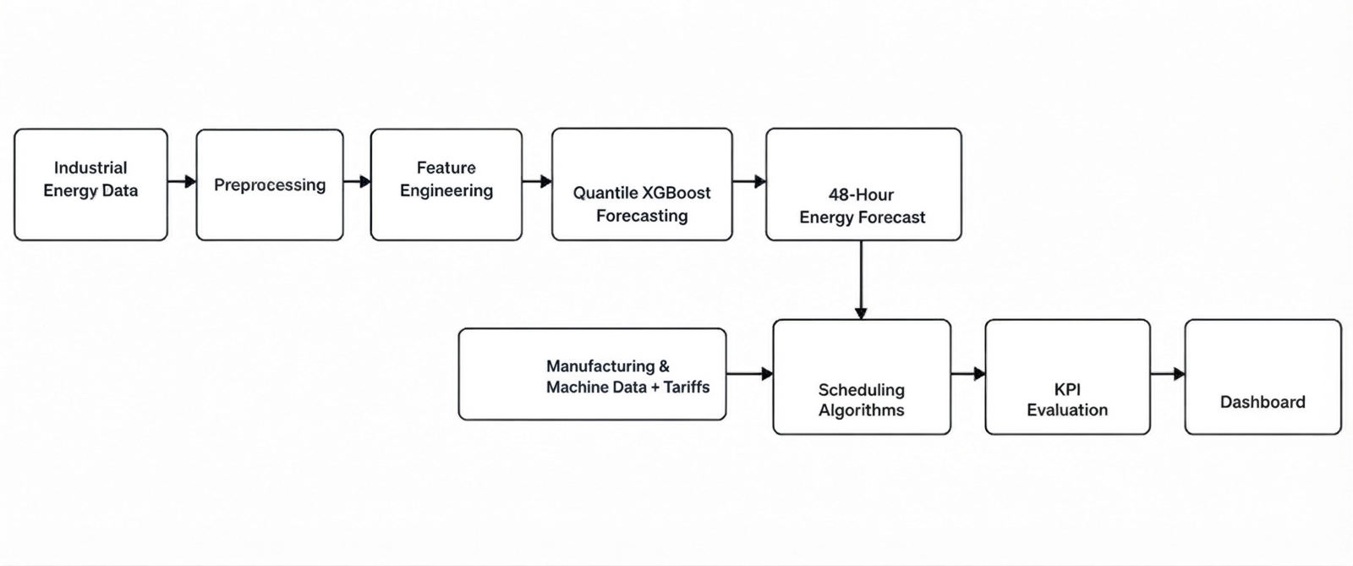
The complete architecture connects the forecasting engine, scheduling engine, KPI calculator, and interactive dashboard as a unified Manufacturing Analytics system.

4.2 Model Selection and Forecasting Methodology
The project uses XGBoost with native quantile regression for energy forecasting and OR-Tools CP-SAT for constraint-based scheduling optimization. The proposed FD-PDTS heuristic provides an energy-aware scheduling solution that can subsequently be used as a warm-start solution for CP-SAT.
Component | Selected Method | Purpose
Energy Forecasting | XGBoost | Predict future industrial energy behaviour
Probabilistic Forecasting | Quantile XGBoost | Generate p10, p50, and p90 forecasts
Scheduling Heuristic | FD-PDTS | Forecast-driven energy-aware job dispatching
Robust Scheduling | FD-PDTS Robust | Incorporate conservative peak-energy risk
Optimization | OR-Tools CP-SAT | Refine schedules under manufacturing constraints
Backend | FastAPI | Provide scheduling and KPI results through APIs
Visualization | Interactive Web Dashboard | Display forecasts, schedules, Gantt charts, and KPIs

XGBoost is suitable for the forecasting stage because the project uses structured industrial SCADA data together with engineered temporal, lag, rolling, and categorical features. The model can capture nonlinear relationships between historical energy consumption and operational or temporal conditions. The implementation uses seven independent XGBoost regressors: p10, p50, and p90 for active energy consumption; p10, p50, and p90 for carbon emissions; and p50 for power factor.
The primary XGBoost configuration is:
Hyperparameter | Value
Number of Estimators | 300
Maximum Depth | 5
Learning Rate | 0.05
Subsample | 0.8
Column Sample by Tree | 0.8
Random Seed | 42

Tariff-based sample weighting is applied during training so that observations occurring during more expensive load periods receive greater importance.
Load Type | Training Weight
Light Load | 1.0×
Medium Load | 1.5×
Maximum Load | 3.0×

The forecasting process generates p10, p50, and p90 predictions representing lower, median, and upper expected conditions. Since independently trained quantile models can produce crossing predictions, an observation-level monotone rearrangement is applied to ensure p10 ≤ p50 ≤ p90. The implementation reduces the quantile crossing rate from 22.6% to 0.00%. During the 48-hour recursive forecast, lag and rolling features are dynamically updated using the generated p50 predictions.

4.3 Scheduling Algorithms and Priority-Based Tariff Shifting
The scheduling component compares conventional scheduling approaches with forecast-driven and optimization-based methods. The benchmark contains 10 scheduling algorithms, including FCFS, SPT, LPT, EDD, Energy-Unaware Greedy, Makespan Greedy, FD-PDTS Deterministic, FD-PDTS Robust, CP-SAT Warm-Start, and CP-SAT Cold-Start.
Algorithm | Type | Main Scheduling Logic
FCFS | Baseline | Processes jobs according to arrival order
SPT | Baseline | Prioritizes shortest processing times
LPT | Baseline | Prioritizes longest processing times
EDD | Baseline | Prioritizes earliest due dates
Energy-Unaware Greedy | Baseline | Deliberately selects higher-power compatible machines
Makespan Greedy | Baseline | Selects machines with the earliest current workload completion
FD-PDTS Deterministic | Proposed Heuristic | Uses p50 forecasts, tariffs, priorities, and peak-load guards
FD-PDTS Robust | Proposed Heuristic | Applies a 1.25× risk multiplier to peak tariff projections and overload risk
CP-SAT Warm-Start | Proposed Hybrid | Refines the FD-PDTS Robust solution using CP-SAT
CP-SAT Cold-Start | Ablation Baseline | Runs CP-SAT without a heuristic warm start

The FD-PDTS method combines forecast information, tariff periods, machine power consumption, job priority, waiting time, machine compatibility, and deadlines when evaluating candidate scheduling decisions. Its objective is to shift flexible operations toward economically favourable periods without violating production constraints.
Priority-based shifting limits provide different levels of flexibility to different jobs:
Priority | Maximum Shift | Maximum Time
High | 0 slots | 0 hours
Medium | 6 slots | 1.5 hours
Low | 8 slots | 2 hours

The deterministic FD-PDTS uses the normal forecast and tariff information, whereas the Robust version incorporates a 1.25× risk multiplier on peak tariff projections together with a peak-overload penalty, making it more conservative when evaluating high-cost or high-load periods.

4.4 Hybrid CP-SAT Optimization and Objective Formulation
The hybrid scheduling approach combines the fast feasible solution produced by FD-PDTS Robust with the constraint-solving capability of OR-Tools CP-SAT. FD-PDTS Robust first generates a feasible energy-aware schedule. This schedule is then supplied to CP-SAT as a warm-start solution or optimization hint. CP-SAT subsequently refines the schedule while enforcing the manufacturing constraints.
The CP-SAT formulation represents job start times, completion times, and machine assignments as decision variables. Each job must be assigned to exactly one compatible machine, jobs assigned to the same machine cannot overlap, and sequence-dependent changeover requirements are incorporated. Job availability, priority-based shifting limits, production deadlines, and the peak grid-load guard are also considered.
The documented optimization objective directly incorporates energy cost, tardiness, and waiting time:
Objective Component | Weight
Energy Cost | 20
Tardiness Penalty | 1000
Waiting Time Penalty | 350

The objective therefore seeks to minimize energy-related cost while strongly penalizing deadline violations and controlling unnecessary waiting. Carbon emissions, peak load, idle energy, and power-factor penalty are calculated as evaluation KPIs, while the active CP-SAT objective directly uses the documented energy-cost, tardiness, and waiting-time terms.
The CP-SAT implementation is evaluated in two configurations. The Warm-Start configuration receives the FD-PDTS Robust solution as an initial hint, while the Cold-Start configuration runs without these hints. This comparison is used as an ablation study to evaluate the contribution of the warm-start strategy.
4.5 Complete Scheduling Methodology and System Implementation
The complete methodology integrates forecasting, scheduling, optimization, KPI calculation, and visualization into a single system. The forecasting module processes historical SCADA data and produces a 48-hour multi-quantile forecast. The scheduling engine then evaluates the generated manufacturing jobs using conventional baselines, energy-aware heuristics, and CP-SAT optimization. The resulting schedules are evaluated using energy, manufacturing, service-level, and environmental KPIs before being presented through the interactive dashboard.
Complete Methodology:
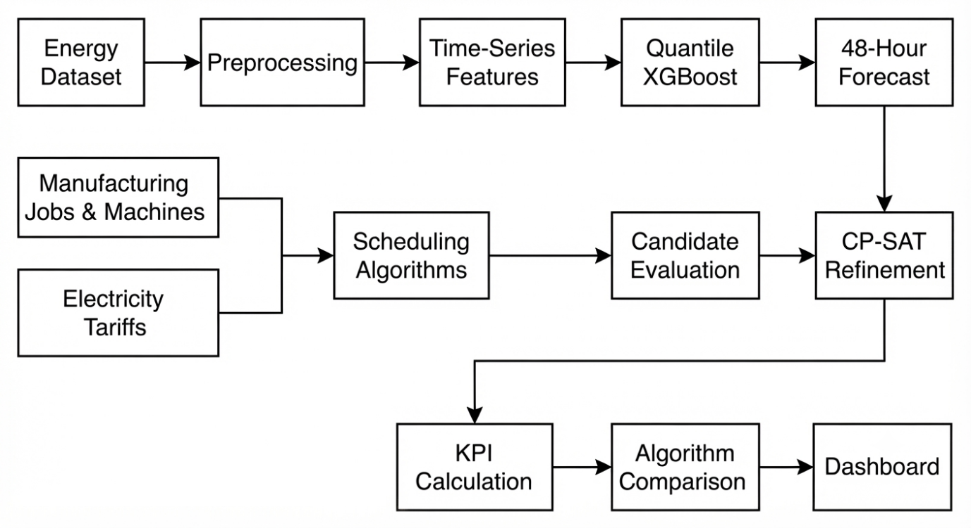
The implementation generates schedules by identifying compatible machines and feasible start times for each job while considering processing duration, machine availability, tariffs, job priority, waiting time, deadlines, machine power consumption, and scheduling constraints. The final schedules are passed to the KPI calculation engine, which evaluates metrics such as total energy cost, peak grid load, carbon emissions, power-factor penalty, makespan, machine utilization, waiting time, delay, and on-time completion. The FastAPI backend exposes these results to the interactive dashboard, which provides schedule visualizations, machine-wise Gantt charts, forecast plots, and algorithm comparisons.

5. METRICS TO MEASURE
5.1 KPI Selection
The project uses a comprehensive set of KPIs to evaluate the performance of different scheduling strategies across energy, manufacturing, service-level, and environmental dimensions. The KPI framework is designed to determine whether reductions in energy cost and peak demand can be achieved without negatively affecting production performance or deadline compliance. The implemented system evaluates 12 KPIs across four operational dimensions.
Dimension | KPI | Purpose | Unit
Energy & Cost | Total Energy Cost | Measures the modeled electricity cost of the schedule | INR (₹)
Energy & Cost | Peak Grid Load | Measures the maximum grid power demand | kW
Energy & Cost | Total Active Energy | Measures total energy consumed while machines actively process jobs | kWh
Energy & Cost | Power Factor Penalty | Measures the modeled surcharge associated with low power factor | INR (₹)
Manufacturing | Makespan | Measures the total schedule completion duration | Hours / Minutes
Manufacturing | Machine Utilization | Measures the percentage of available machine capacity used for processing | %
Manufacturing | Average Waiting Time | Measures the average time jobs remain waiting after becoming available | Minutes
Manufacturing | Total Idle Time | Measures non-processing machine time during the makespan | Minutes
Service Level | Total Delay | Measures cumulative delay beyond job deadlines | Minutes
Service Level | Late Jobs Count | Counts jobs completed after their deadlines | Count
Service Level | On-Time Completion | Measures the percentage of jobs completed within their deadlines | %
Environmental | Carbon Emissions | Measures the modeled carbon emissions associated with energy consumption | tCO₂

5.2 Energy and Cost Performance Metrics
Total Energy Cost is the primary economic KPI and measures the modeled electricity cost associated with machine operation throughout the schedule. It incorporates active energy consumption together with applicable idle and setup costs and is evaluated against the corresponding Time-of-Use tariff periods. A lower value indicates a more economically efficient scheduling strategy. The implemented KPI calculation represents total energy cost using active energy, tariff cost, idle cost, and setup cost components.
Peak Grid Load measures the maximum modeled power demand occurring at any point during the scheduling horizon. It reflects the combined power consumption of simultaneously operating machines and the baseline grid load. Reducing this value is important because simultaneous operation of high-power machines can increase demand and create excessive grid loading.
Total Active Energy measures the total energy consumed by machines while actively processing jobs. This metric helps distinguish reductions in electricity cost caused by tariff shifting from reductions in actual energy consumption. Power Factor Penalty measures the modeled surcharge associated with forecasted power-factor values below the specified 0.90 threshold.

5.3 Manufacturing and Production Performance Metrics
Makespan represents the total time required to complete the manufacturing schedule, calculated from the earliest job start to the latest job completion. It provides an indication of overall production duration and allows the effect of energy-aware scheduling on production efficiency to be evaluated.
Machine Utilization measures the proportion of available machine capacity that is used for active processing during the schedule. Higher utilization generally indicates more effective use of available manufacturing resources, while lower utilization may occur when jobs are intentionally shifted to different tariff periods.
Average Waiting Time measures the average time between a job's arrival or availability and its actual processing start. This metric is particularly relevant to the proposed approach because flexible jobs may intentionally wait for more favourable tariff or energy conditions. Total Idle Time measures the total non-processing time of machines within the makespan and helps identify the operational impact of job shifting and machine allocation decisions.

5.4 Service-Level and Environmental Metrics
Total Delay measures the cumulative amount of time by which jobs exceed their specified deadlines. Late Jobs Count represents the number of jobs whose completion occurs after their deadlines. On-Time Completion represents the percentage of jobs completed on or before their deadlines. These service-level metrics ensure that energy-cost and peak-load reductions are not achieved at the expense of unacceptable production delays.
Carbon Emissions provide the environmental dimension of the evaluation. The metric estimates emissions associated with energy consumption and forecasted carbon-related conditions throughout the scheduling horizon. It allows different scheduling strategies to be compared not only according to economic performance but also according to their potential environmental impact.
The Power Factor Penalty is included as an electrical-efficiency KPI and represents the modeled penalty when forecasted power factor falls below the defined threshold. The project documentation records this metric as part of the 12-KPI evaluation framework.

5.5 Multi-Dimensional Evaluation
No single KPI is sufficient to evaluate an energy-aware manufacturing schedule. A scheduling method that minimizes electricity cost may increase waiting time or production duration, while a method that minimizes makespan may perform poorly during expensive tariff periods. Similarly, reducing peak demand should not result in excessive deadline violations or poor machine utilization.
Therefore, the project evaluates scheduling performance across four complementary dimensions: Energy & Cost, Manufacturing Performance, Service Level, and Environmental Performance. The combination of these KPIs provides a broader assessment of whether the proposed FD-PDTS and hybrid CP-SAT approaches can improve energy and cost performance while maintaining production requirements and deadline compliance.

6. RESULT REVIEW
6.1 Benchmark Results
The proposed scheduling framework was evaluated using a 20-seed empirical benchmark consisting of independent synthetic manufacturing instances generated using seeds 42–61. Each instance contains 160–200 manufacturing jobs and 8 heterogeneous machines over a 48-hour planning horizon. The evaluation compares conventional scheduling methods, energy-aware FD-PDTS approaches, and CP-SAT-based optimization methods using energy, production, service-level, and environmental KPIs.
The aggregate benchmark results are presented below.
Algorithm | Energy Cost (₹) | Peak Grid Load (kW) | Carbon Emissions (tCO₂) | On-Time Completion
FCFS | ₹187,371.53 ± 5,607.45 | 784.48 ± 0.00 | 735.87 ± 32.70 | 100.0%
Energy-Unaware Greedy | ₹191,935.57 ± 5,687.44 | 784.48 ± 0.00 | 768.07 ± 35.66 | 100.0%
Makespan Greedy | ₹187,168.68 ± 5,940.02 | 784.48 ± 0.00 | 736.69 ± 34.21 | 100.0%
SPT | ₹171,576.08 ± 4,278.27 | 762.53 ± 15.57 | 799.50 ± 34.94 | 98.6%
EDD | ₹183,513.60 ± 5,814.67 | 782.73 ± 3.66 | 758.66 ± 33.45 | 100.0%
FD-PDTS Deterministic | ₹169,841.13 ± 6,606.72 | 780.73 ± 7.85 | 683.86 ± 39.06 | 100.0%
FD-PDTS Robust | ₹169,397.15 ± 6,877.50 | 780.73 ± 7.85 | 686.43 ± 40.83 | 100.0%
CP-SAT Warm-Start (Hybrid) | ₹127,254.28 ± 5,309.53 | 491.58 ± 33.16 | 558.80 ± 35.00 | 100.0%
CP-SAT Cold-Start | ₹88,827.30 ± 4,804.01 | 153.43 ± 22.16 | 672.47 ± 35.69 | 93.2%

The CP-SAT Warm-Start Hybrid provides the strongest balanced performance among the evaluated approaches. Compared with FCFS, it achieves substantial reductions in energy cost, peak grid load, and carbon emissions while maintaining complete deadline compliance.

6.2 Energy Cost and Production Performance
The Hybrid CP-SAT approach reduces the modeled energy cost compared with the FCFS baseline. The comparison between the two methods is summarized below.
Metric | FCFS | CP-SAT Warm-Start (Hybrid) | Improvement / Difference
Total Energy Cost | ₹187,371.53 | ₹127,254.28 | 32.1% reduction
Peak Grid Load | 784.48 kW | 491.58 kW | 37.3% reduction
Carbon Emissions | 735.87 tCO₂ | 558.80 tCO₂ | 24.1% reduction
Power Factor Penalty | ₹30,660.46 | ₹20,431.24 | 33.4% reduction
On-Time Completion | 100.0% | 100.0% | 0 late jobs
Average Waiting Time | 54.6 min | 93.9 min | 39.3 min increase

The reduction in energy cost is associated with forecast-driven scheduling, tariff-aware job shifting, machine assignment, peak-load considerations, and CP-SAT refinement. The increase in average waiting time reflects the intentional postponement of flexible jobs when alternative processing periods provide more favourable energy or tariff conditions.
The Hybrid CP-SAT approach therefore demonstrates a trade-off between energy performance and waiting time. Instead of processing every job as early as possible, the scheduler can allow flexible jobs to wait when this contributes to improved energy and cost performance while still satisfying the required production constraints.

6.3 Peak Load, Deadline and Environmental Performance
Peak grid load is significantly reduced by the Hybrid CP-SAT approach. The comparison with the FCFS baseline is shown below.
Performance Measure | FCFS | CP-SAT Warm-Start | Reduction
Peak Grid Load | 784.48 kW | 491.58 kW | 37.3%
Carbon Emissions | 735.87 tCO₂ | 558.80 tCO₂ | 24.1%
Power Factor Penalty | ₹30,660.46 | ₹20,431.24 | 33.4%
On-Time Completion | 100.0% | 100.0% | 0 late jobs
Late Jobs | 0 | 0 | No increase

The reduction in peak grid load indicates that the Hybrid CP-SAT approach can distribute machine operations more effectively and reduce simultaneous high-power machine activity. The carbon-emission reduction also demonstrates the environmental benefit associated with the energy-aware scheduling strategy.
All jobs in the Hybrid CP-SAT benchmark are completed on time. This is particularly important because energy-aware scheduling may intentionally delay flexible jobs. The results show that the additional scheduling flexibility does not result in deadline violations for the Hybrid approach.
The comparison between the two CP-SAT configurations further demonstrates the importance of warm-starting.
Metric | CP-SAT Warm-Start | CP-SAT Cold-Start
Energy Cost | ₹127,254.28 | ₹88,827.30
Peak Grid Load | 491.58 kW | 153.43 kW
Carbon Emissions | 558.80 tCO₂ | 672.47 tCO₂
On-Time Completion | 100.0% | 93.2%
Late Jobs per Instance | 0.0 | 12.25
Average Delay | — | 445 min

Although CP-SAT Cold-Start achieves lower modeled energy cost and peak load, it performs poorly in terms of deadline compliance. It produces only 93.2% on-time completion, with an average of 12.25 late jobs and 445 minutes of delay per instance. The Hybrid Warm-Start approach maintains 100% on-time completion while achieving substantial energy and peak-load reductions. This demonstrates the importance of providing CP-SAT with a feasible FD-PDTS Robust warm-start solution.

6.4 Overall Comparison and Interpretation
The benchmark results demonstrate that conventional production-oriented scheduling and energy-aware scheduling produce different performance characteristics. FCFS, EDD, and other baseline approaches generally maintain strong deadline compliance but do not explicitly optimize the energy and tariff dimensions. FD-PDTS improves energy-related performance by incorporating forecast information and tariff-aware scheduling, while the Hybrid CP-SAT approach further refines the schedule under manufacturing constraints.

The overall improvement of the Hybrid CP-SAT approach relative to FCFS is summarized below.
KPI | FCFS Baseline | Hybrid CP-SAT | Overall Improvement
Energy Cost | ₹187,371.53 | ₹127,254.28 | 32.1% lower
Peak Grid Load | 784.48 kW | 491.58 kW | 37.3% lower
Carbon Emissions | 735.87 tCO₂ | 558.80 tCO₂ | 24.1% lower
Power Factor Penalty | ₹30,660.46 | ₹20,431.24 | 33.4% lower
On-Time Completion | 100.0% | 100.0% | Maintained
Average Waiting Time | 54.6 min | 93.9 min | Higher by 39.3 min

These results indicate that the proposed framework can achieve substantial improvements in energy and environmental performance without sacrificing deadline compliance in the evaluated benchmark. The main trade-off is increased waiting time, as flexible jobs can be intentionally shifted away from expensive or high-load periods.

6.5 Dashboard and Visualization
The developed dashboard provides an interactive representation of the forecasting, scheduling, and KPI results. It presents scorecards for major performance indicators and provides visual comparisons between scheduling algorithms. The dashboard also includes machine-wise Gantt charts and a 48-hour multi-quantile energy forecast with tariff-period information.
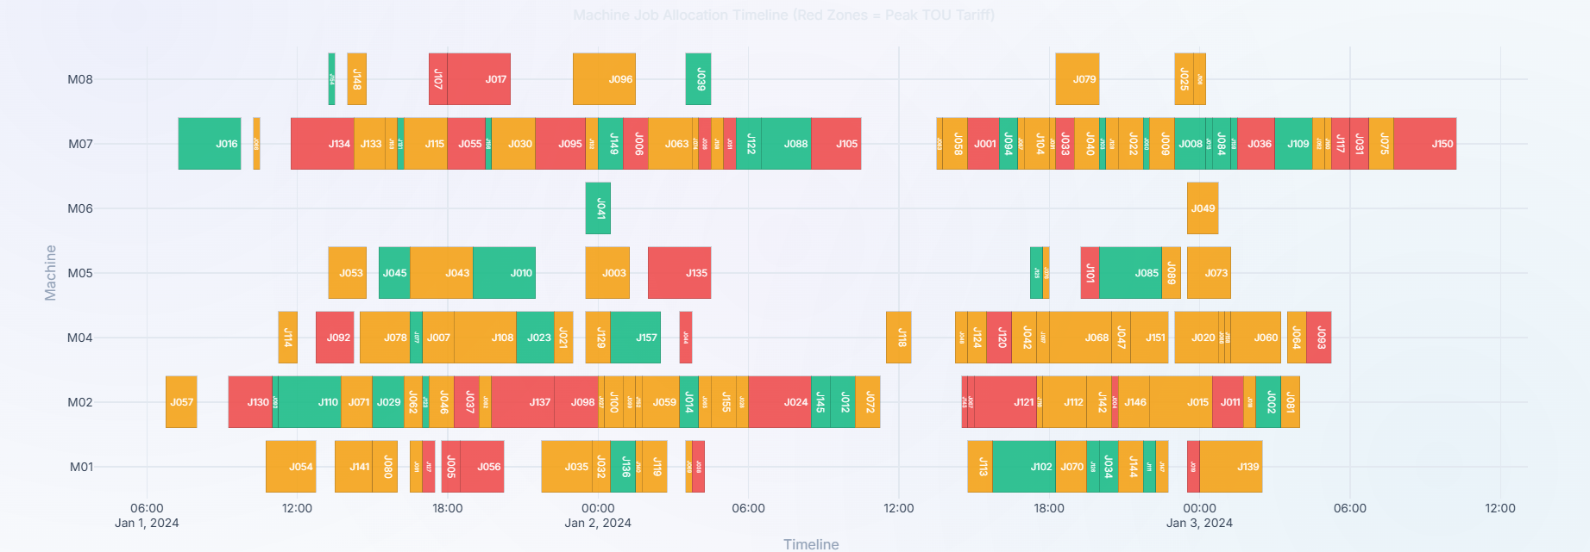
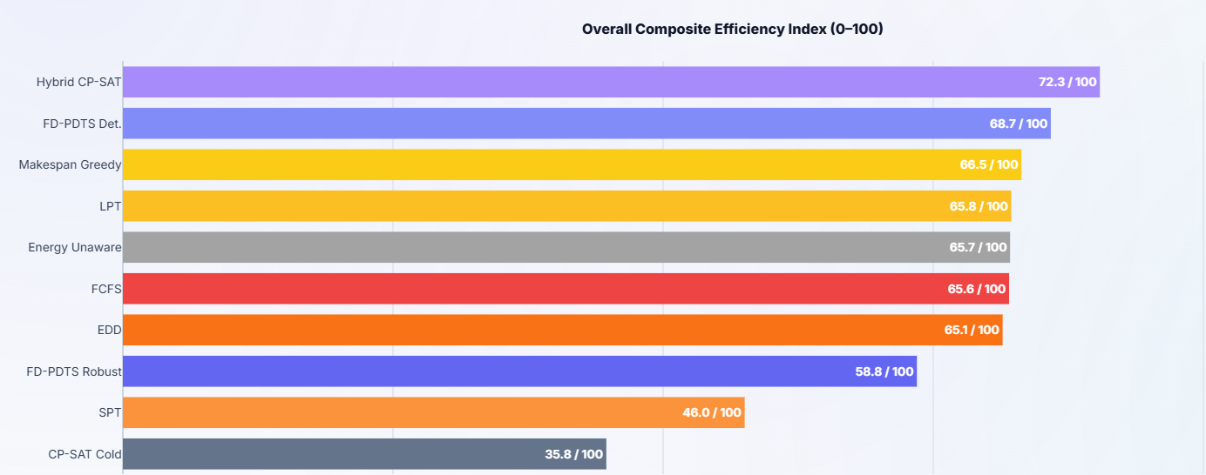
6.6 Result Limitations
The results should be interpreted within the scope of the current research prototype. The scheduling evaluation uses synthetic manufacturing instances rather than real job-level production records from the industrial SCADA dataset. The benchmark also deliberately uses a peak-biased arrival distribution, with approximately 70–80% of job arrivals occurring during Maximum-Load tariff periods. This creates an appropriate test environment for evaluating tariff-aware scheduling, but it may also favour approaches capable of shifting flexible jobs away from peak periods.
The forecasting and scheduling results therefore demonstrate the behaviour of the implemented framework under the defined experimental conditions rather than establishing universal performance across all manufacturing environments. The project uses 20 independent benchmark seeds to improve the reliability of the evaluation, while the current implementation also documents several v2 improvements, including quantile non-crossing, power-factor rescaling, recursive forecasting updates, differentiated scheduling algorithms, and multi-seed validation.

